hp

Team Members

Dnyaneshwar Sampat Khedkar

Kiran Bhausaheb Shinde

BEHAVIOUR BASED DROWSINESS DETECTION

BEHAVIOUR BASED DROWSINESS DETECTION

# Team Members:

1. Dnyaneshwar Sampat Khedkar.
2. Kiran Bhausaheb Shinde.

# PROBLEM STATEMENT:

According to the latest statistical data, road accidents result in over 1.35 million deaths and 20 to 50 million non-fatal injuries each year. Driver

drowsiness involves physical as well as physiological changes. In which, physical changes involve sleeplessness while physiological changes involve the rate of actions and reactions taken by the driver. As a result, the driver may have a slow reaction time, reduced vigilance, and impaired thinking. In the worst case, the driver may fall asleep behind the wheel. To this end, the research on the recognition of driver drowsiness is important for improving road traffic safety and is a significant and active research area.

There has been number of methods proposed to reduce the accidents due to drowsiness, but this paper focuses on this model to be,

1. Cost-efficient: We need the model to be affordable, and yet effective
2. Non-Intrusive - A simple camera properly placed in front of the driver should be sufficient to make good predictions. The model should not occupy much space that it disturbs the driver in anyway.
3. Accurate – All of the above conditions should be met as much as possible without compromising the accuracy of the predictions.

## BUSINESS/MARKET/CUSTOMER NEED ASSESSMENT:

As we know, nowadays people experience a lot of fatigue and stress, either because of work or personal problems. This leads to sleeplessness or tiredness in morning as well as night. And these effects doesn’t show up giving signals, it can put a person in sleep gradually without even the victim noticing, this can be fatal especially when the person is driving, where the person should drive with utmost focus on the

road. Nowadays, Driving has become almost a necessity for most of the people, from cab drivers to office workers, so in many cases , even if the person is drowsy or tired, it is not often possible to avoid driving. Especially when person has a need to drive at nights, then the situation becomes a bit more dangerous, as human mind automatically tends to fall asleep at quite nights. This demands for taking appropriate measures for the **safety of the driver**, which the automobile industry has put a lot of efforts to achieve. So, drowsiness detection is a big step towards achieving the safety of driver and avoiding accidents due to fatigue and tardiness.

## TARGET SPECIFICATION AND CHARACTERISATION:

Automobile industries have come a long way over the past decades. As much as the producers focus on convenience and efficiency of their product, the most important thing they keep in mind is safety of the driver.

This model mainly focuses on the need of automobile industry. As we all know, automobile industry has seen some drastic improvements over past few decades. We are now slowly converting the mode of transportation to electric vehicles , gradually replacing the ones that require fossil fuels. Over the years, the automobile industry thrived to develop a more eco-friendly, convenient and most importantly **safe** transportation for its users. Addition of drowsiness detection models, to the new upcoming electric cars, is definitely a big step towards the safety of the driver. With these new added features in a user’s car , the driver is always assured a sense of safety.

One way to meet the demands is to embed the mechanism (a small webcam in an appropriate position) directly into the car, during the process of manufacturing. The other way is to sell portable devices of such drowsiness detection models, which is attachable to the cars, this way , the customers might receive the services irrespective of the car they have, this gives customers more flexibility.

## EXTERNAL RESOURCES:

### Links :

* A Portable Fuzzy Driver Drowsiness Estimation System <https://www.mdpi.com/1424-8220/20/15/4093/htm>
* Driver Fatigue Detection Based on Convolutional Neural Networks Using EM-CNN: <https://www.hindawi.com/journals/cin/2020/7251280/>
* Preventing Drowsy-Driving Accidents Using Convolutional Neural Networks: [https://towardsdatascience.com/drowsiness-detection-using-convolutional-](https://towardsdatascience.com/drowsiness-detection-using-convolutional-neural-networks-face-recognition-and-tensorflow-56cdfc8315ad) [neural-networks-face-recognition-and-tensorflow-56cdfc8315ad](https://towardsdatascience.com/drowsiness-detection-using-convolutional-neural-networks-face-recognition-and-tensorflow-56cdfc8315ad)
* Detecting Driver Drowsiness Based on Sensors: A Review [https://www.ncbi.nlm.nih.gov/pmc/articles/PMC3571819/#:~:text=Another%2](https://www.ncbi.nlm.nih.gov/pmc/articles/PMC3571819/#%3A~%3Atext%3DAnother%20limitation%20of%20SDLP%20is%2Cerror%20risk%20due%20to%20drowsiness) [0limitation%20of%20SDLP%20is,error%20risk%20due%20to%20drowsiness](https://www.ncbi.nlm.nih.gov/pmc/articles/PMC3571819/#%3A~%3Atext%3DAnother%20limitation%20of%20SDLP%20is%2Cerror%20risk%20due%20to%20drowsiness)

### Papers:

* Driver drowsiness detection system under infrared illumination for an intelligent vehicle,M.J. Flores, 2011.
* A Partial Least Squares Regression- Based Fusion Model for Predicting the Trend in Drowsiness,2008, Hong Su.
* Camera based Drowsiness Reference for Driver State Classification under Real Driving Conditions, June,2010, Bin Yang.

#### BENCHMARKING ALTERNATE PRODUCTS:

In recent cars, the drowsiness detection uses environmental factors such as :

* + Steering Wheel Movement(SWM):

SWM is measured using steering angle sensor and it is a widely used vehicle-based measure for detecting the level of driver drowsiness. Using an angle sensor mounted on the steering column, the driver’s steering behaviour is measured. When drowsy, the number of micro-corrections on the steering wheel reduces compared to normal driving. Hence, based on small SWMs, it is possible to determine the drowsiness state of the driver and thus provide an alert if needed. Car companies, such as Nissan and Renault, have adopted SWMs but it works in very limited situations .This is because they can function reliably only at particular environments and are too dependent on the geometric characteristics of the road.

#### Standard Deviation of Lane Position (SDLP)

SDLP is another measure through which the level of driver drowsiness can be evaluated. In a simulated environment, the software itself gives the SDLP and in case of field experiments the position of lane is tracked using an external camera. Main limitation of SDLP is that it is purely dependent on external factors like road marking, climatic and lighting conditions.

In summary, many studies have showed that vehicle based predictions of drowsiness is a very poor predictor. So, this model concentrates on the behavioural aspect of the driver. That is, it focuses whether the driver is closing his or her eyes, or yawning. As facial expressions are a direct indicator whether a person is sleeping or not, a model which uses facial expressions to detect the driver is sleeping or not, seems to be a relatively reliable model in predicting whether a person is drowsy or not. And also, as only a camera is needed to do the prediction , this model is non-intrusive as it doesn’t have contact with the driver or doesn’t disturb the driver. So hence, this model is non-intrusive compared to physiological methods used for drowsiness detection ( such as using psychological signals like ECG, EMG,EEG) which might need sensors to come in contact with the driver. And also mainly, as only a camera is required for behaviour based predictions, it is very cost efficient when compared to other methods used for drowsiness detection.

Most importantly, for the above discussed physiological and vehicle based predictions , the mechanism needs to be inbuilt along with the vehicle during the process of manufacturing. But for behaviour based predictor model, not only that it can be inbuilt along with the vehicle during the process of manufacturing , also we can make portable devices having the software/mechanism of the drowsiness detection, which is attachable to the user’s cars, which provides the customers with much more flexibility.

The main limitation of using a vision-based approach is lighting. Normal cameras do not perform well at night. In order to overcome this limitation, we can use IR camera to capture an image of the driver, to predict whether he/she is sleeping. By this, the model will be able to capture image clearly even when it is dark.

#### APPLICABLE PATENTS:

**Automobile camera system** (**US20030041329A1**) : An automobile camera system which employs a detection and imaging system, including a force and motion detector sensor system, a wireless Internet network interface, and a digital/web camera network for capturing video and related audio data. The system is configured for vehicles to capture image data of intruders within and outside a vehicle. Data captured in these respective modes are transmitted wireless to a laptop or any other device which contains the software of drowsiness detection where we can run the code and predict whether the person is sleeping or not. Even though a rudimentary model can be implemented without this patent, using the “Automobile camera system” opens up a wide variety of opportunity and development. For example, we can use the motion detection sensor, if the driver is grossly away from his position, like tilted left or right while sleeping, even then we can signal the alarm. And for another example, as we have wireless internet network interface in the Automobile camera system, along with signalling the alarm, notifying and sending them the live location of the driver to the family and friends through the wireless communication will be helpful in case the driver is unconscious and needs emergency help.

#### REGULATIONS:

As in the drowsiness detection model, we should monitor the private space of a person, that is, inside his/her car to predict whether a person is drowsy or not, we have to take care of the data that is captured by the camera. Because if the camera is taken control by hackers/ wrong people in the internet, then they would take the video information of the user and misuse it.

To protect the personal information of the users by companies, the Indian Government has introduced The Personal Data Protection Bill, 2019 in Lok Sabha by the Minister of Electronics and Information Technology. The Bill seeks to provide for protection of personal data of individuals, and establishes a Data Protection Authority for the same.

The Bill governs the processing of personal data by: (i) government, (ii) companies incorporated in India, and (iii) foreign companies dealing with personal data of individuals in India. Personal data is data which pertains to characteristics, traits or

attributes of identity, which can be used to identify an individual. Now, as a camera in car observes a person in his/her private space, the data captured from the camera is considered as personal information, and it should be protected from hackers.

And also, as we are using sound, alarm, to alert the user and wake him/her from sleeping

, we should not keep the sound too loud such that it disturbs the other persons on the road, especially during night we do not need a very loud noise, which might disturb fellow drivers and is also not encouraged in hospital zones. And also there should not be any possibility where the sound of the alarm disturbs the driver and causes any unwanted situations. Even though a very loud sound is not necessary in most of the cases, this point also should be kept in mind, to avoid any cases of public nuisance. According to Noise Pollution (Regulation and Control) Rules, 2000 Act, The noise level at the boundary of the public place, where loudspeaker or public address system or any other noise source is being used shall not exceed 10 dB above the ambient noise standards for the area or 75 dB whichever is lower. So we can have set the alarm sound at a reasonable level, high enough to wake up the driver and low enough not cause any pollution.

#### APPLICABLE CONSTRAINTS:

Gathering Data : For this model, collecting various eye images of people is a tedious task. For the model to be as reliable as possible, we have to make sure that the images of the eyes are taken under different lightings and angles, so that the model would be able to detect drowsiness even under experiment conditions. As it is not possible to consider all the possibilities, we have to consider as many angles and lightings as possible. We have to also consider the different types of eye structures, that is to consider the eye images of people from different countries, so that it can be used by various customers with proper accuracy.

Data Pre-processing : As the data for the model is images ( as video is a sequence of images) , pre-processing of data might be relatively difficult (which includes resizing the image, adjusting the brightness etc).

#### BUSINESS OPPORTUNITY:

The Automotive Industry has seen a significant growth over the past few decades. The industry has focused to make the vehicles more convenient and more eco- friendly, because of increasing environmental concerns. But the most important thing, that the manufacturers have concentrated is the safety of the drivers. This model is a big step towards improving the safety of the driver, not only that we can have inbuilt mechanism in the car, built during the process of manufacturing, we can also have portable drowsiness detection devices which is attachable to the user’s cars, this provides the customers with more flexibility and also makes the model accessible to general public. And also, this device can be improved constantly, with new

improvements and developments. For example, if a person is not waking up even after the alarm beeping for some amount of time, then we can have mechanism such that the vehicle will halt gradually, ensuring the safety of the driver

#### CONCEPT GENERATION:

As behavioural characteristics, such as facial expressions are directly affected when the person is drowsy or not, they are the most reliable way to check predict whether a person is drowsy or not. So we can use a camera, to continuously monitor whether a person is sleeping or not and we can beep the alarm if the model predicts that the person is sleeping.

#### CONCEPT DEVELOPMENT:

Here, as we have the basic idea to alert the person when he/she is classified as sleeping, the main question when do we classify if a person is sleeping or not. We cannot directly classify a person to be drowsy from a single instance/frame, as we have the input data as a video, we have to consider the stream of images before we take a decision. To implement this, we use a CNN classifier to classify whether a person is sleeping or not given a image of a face. And we take 100 instances, that is 100 frames into consideration continuously, and compute what the classifier is predicting at each of the 100 instances, and collectively we take a decision on whether the person is feeling drowsy or not, usually we do this by setting a threshold and when the percentage of awake instances is less than the threshold, we consider the driver to be drowsy and we can now sound the alarm.

#### FINAL PRODUCT PROTOTYPE (ABSTRACT) WITH SCHEMATIC DIAGRAM:

The schematic diagram for behaviour based drowsiness detection is given below. Here this model’s purpose is to detect the face and extract ROI, which is eye region in this case, and the we consider the predictions for a specific interval of time and we collectively take a decision to check whether the person is drowsy or not. And then we sound the alarm if a person is considered to drowsy. By this we can alert the user, if he/she feels drowsy. As behavioural characteristics such as facial expressions is directly impacted by whether a person is drowsy or not, they are the most reliable method for drowsiness detection.

Schematic diagram of the model:

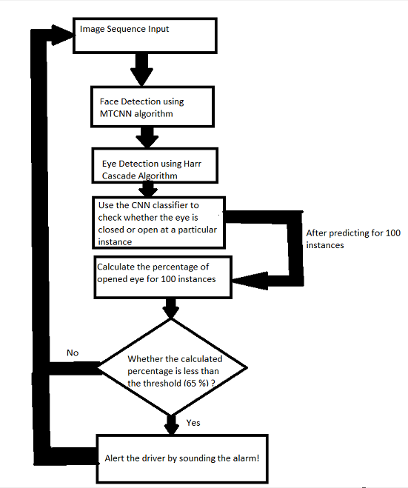

#### PRODUCT DETAILS:

**HOW IT WORKS:**

Firstly, we detect the face from a given image (from video) using the multitask cascaded convolution neural networks algorithm (MTCNN) and after we detect the face, we detect the region of interest which is eyes in this case. We detect the eyes of the face using Harr Cascade algorithm. This difference in algorithms for eye and face detection is just to use a combination of algorithms for variation. And we use CNN classifier model, to predict whether the eye is closed or not for a particular instance. And like this, we consider 100 more instances and for each instance we predict whether the eye is open or close. Then we actually calculate the percentage of open eyed instances for 100 instances, and we check whether the calculated percentage is lesser than the threshold ( 65%) and if it is lesser then the person is considered to be drowsy. And if he is drowsy, we sound the alarm to wake him/her up.

For calculating the open eyed instances percentage, we consider a list of 100 elements, with all elements as 1, indicating the person is 100% awake initially. And for each instance , that is each frame getting captured, we pop the element in the beginning irrespective of whether it is open or closed eye, And if it open eye , we add 1 at the end

and if it closed eye, we add 0 at the end if it is closed eye. And for each instance we compute the average of the elements in the list, which is basically the open eyed instance percentage. If the percentage is lesser than 65% then the person is considered as drowsy, and we sound the alarm to wake the driver.

Note: Generally the percentage is only reduced by 1% if a person is drowsy, for each instance. So to gradually increase the amount by which the percentage is decreasing , we can have variable which keeps incrementing for each instance if the person is continuously in the same state. And then add/subtract the increasing variable until we have reached either extremes (0% or 100%).

#### DATASOURCES:

Thousand’s of images are used in the CNN classifier , so that it can learn from the eye images taken from different angles and lightings. We have to make sure that most of the possibilities, like angles and lightings, is covered. So, that it will be able to predict accurately from different positions.

We have to make sure that number of close eyed and open eyed images is equal in number, that is to make sure that we have balanced dataset.

And also we have to pre-process the dataset properly, like resizing the images and adjusting the brightness of the images.

#### ALGORITHMS:

A **Convolutional Neural Network** is a Deep Learning algorithm which can take in an input image, assign importance (learnable weights and biases) to various aspects/objects in the image and be able to differentiate one from the other. CNNs are used for image classification and recognition of region of interest like face, eyes because of its high accuracy (99% accurate). We can use this algorithm model, to predict whether the eye is closed or not at a particular instance.

**Multi-task Cascaded Convolutional Networks (MTCNN)** is a framework developed as a solution for both face detection and face alignment. But

for this model we use it for face detection.

**Harr Cascade** is an Object Detection Algorithm used to identify faces/ facial features in an image or a real time video. The algorithm is given a lot of positive images consisting of faces, and a lot of negative images not consisting of any face to train on them. The pre trained model has the models stored in XML files, and can be read with the OpenCV methods. These include models for face detection, eye detection, upper body and lower body detection, license plate detection etc.

**COST** : The cost of the model is actually the cost of a basic camera for portable drowsiness detection devices and for inbuilt drowsiness detection mechanism in the car, there will be an additional installation costs, and also we have to include the cost of a small portable speaker, as all the software used is open-source and language used is python

#### CONCLUSION:

Drowsiness detection based on behaviour is a big step towards improving the safety of the driver. This model is most importantly cost efficient and accessible to the public. With extremely reliable model, we can have cars or night trucks with cameras installed in the front, and when the driver is feeling sleepy or drowsy we can sound the alarm. This provides the drivers with sense of security and also reduce the chance of accidents drastically. The main advantage of the model is that there is endless extensions

/improvements possible to this model to make it more promising. For example, In the worst case ,if the driver faints or renders unconscious ,alarm will be useless. So, we can set a period of time, threshold period beyond which we can program the car or truck to either halt smoothly or shift the control to auto pilot. It can really be a significant improvement in the automobile industry.

# SaaS Business Model:

The premise of the **software-as-a-service or SaaS model** is that a piece of software is hosted on a cloud infrastructure (i.e., operated through a web browser), and businesses pay a monthly fee to get access to this software. It often takes a good amount of coding knowledge, combined with a good amount of user interface design skills, to really make a SaaS product worthwhile.

SaaS businesses in general are probably the most complex business models in our explainer series.

The main difference between SaaS businesses and software companies is that SaaS is hosted in the cloud. Basically, this gets rid of the need for an end user license to activate the software and any infrastructure to host the software. Instead, the SaaS company hosts their membership. The customer just has to log into their account and they get full access.

**Feasibility**: This project can be developed and deployed within a few years as SaaS( Software as a Service) for anyone to use.

**Viability:** As the retail industry grows in India and the world, there will always be small businesses existing which can use this service to improvise on their sales and data warehousing techniques. So, it is viable to survive in the long-term future as well but improvements are necessary as new technologies emerge.

**Monetization**: This service is directly monetizable as it can be directly released as a service on completion which can be used by businesses.

# FINANCIAL MODELING:

Deriving the time equation x(t):

Trend of number of patents applied over 20 years:

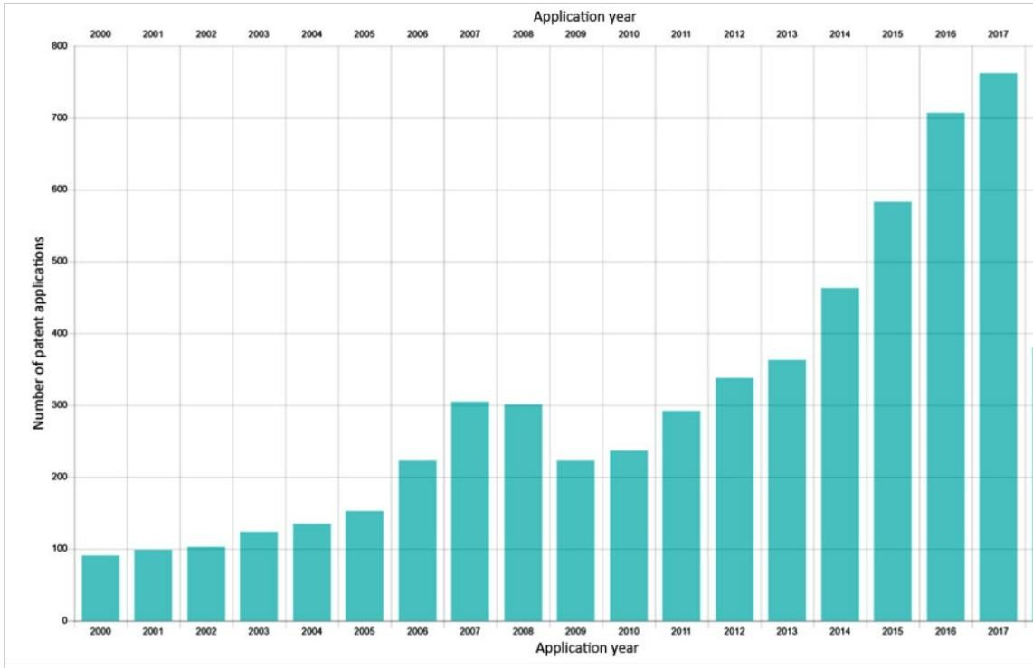

Table of the above trend:

|  |  |  |  |
| --- | --- | --- | --- |
| Year | Number of patents  applied | Choosing the best degree of the polynomial: | |
| 2000 | 95 |
| 2001 | 100 |
| 2002 | 105 |
| 2003 | 130 |
| 2004 | 140 |
| 2005 | 150 |
| 2006 | 220 |
| 2007 | 310 |
| 2008 | 300 |
| 2009 | 220 |
| 2010 | 230 |
| 2011 | 295 |
| 2012 | 340 |
| 2013 | 360 |
| 2014 | 460 |
| 2015 | 590 |
| 2016 | 710 |
| 2017 | 750 |
| Degree | | | R2 |
| 1 | | | 0.83 |
| 2 | | | 0.93 |
| 3 | | | 0.91 |
| 4 | | | 0.94 |
| 5 | | | 0.73 |

A good R2 score ,0.927 , is seen when the degree of the polynomial is 2. Hence, we can decide the polynomial degree to be 2.

Note: Even though degree of 4 is polynomial gives slightly better r2 , it is better to not assume such rapid growth. And stick with more realistic equation.

Plotting a graph of Year vs Number of patents applied:

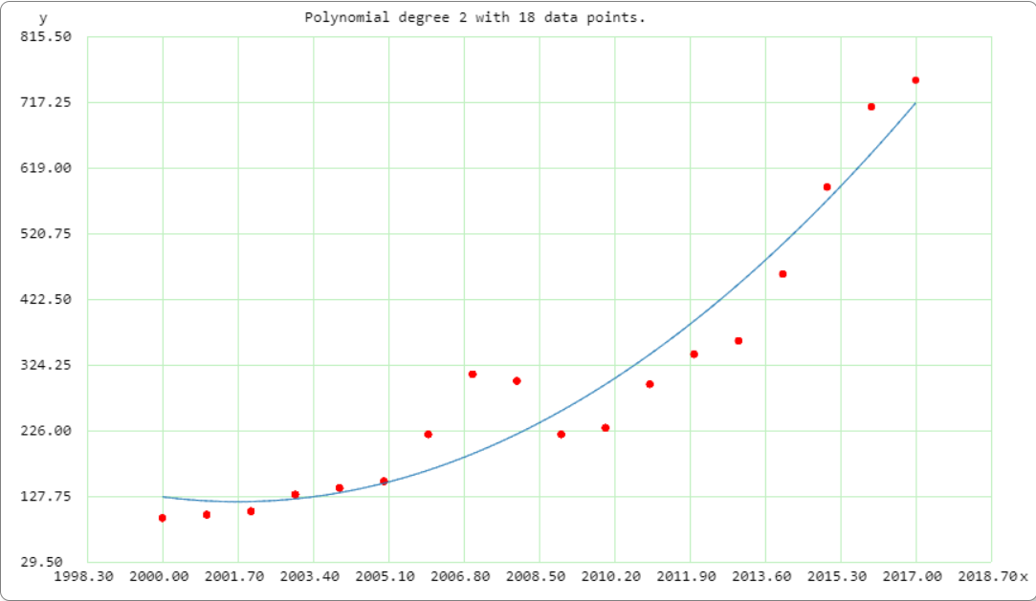

The time dependent equation of number of patents applied as a function of time is; x(t) = 1.0210951057791537 x 107 - t x 1.0202161377708977 x 104 +

t2 x 2.5483746130030958

## Estimating m and c :

Executive Team of 5 members:

₹50,000* 5 = ₹2,50,000

Infrastructure and technology :

₹ 50,000

Maintenance and upgradation cost(yearly) : ₹1,00,000

So, Total cost = ₹4,00,000

Profit percentage (for 2017)= 25% Number of patents in 2017 = 750 **Financial Equation:**

### Y = m* x(t) –c

x(t) = 1.0210951057791537 x 107 - t x 1.0202161377708977 x 104 +

### t2 x 2.5483746130030958

So subscription price = 1.25 *4,00,000/750 = ₹700 So m = ₹700 and c= ₹4,00,000